Rotary Club of Kathmandu Mid-Town
Breakfast Chatter




21 October 2011 The Weekly Bulletin of Rotary Club of Kathmandu Mid-Town Bc-10.21/011-12

District: 3292 Web: www.rotarymidtown.org.np Club Id : 26776

OCTOBER IS THE VOCATIONAL SERVICE MONTH
Declaration of Rotarians in Businesses and Professions:
As a Rotarian engaged in a business or profession, I am expected to:
1) Consider my vocation to be another opportunity to serve;
2) Be faithful to the letter and to the spirit of the ethical codes of my vocation, to the laws of my country, and to the moral standards of my community;
3) Do all in my power to dignify my vocation and to promote the highest ethical standards in my chosen vocation;
4) Be fair to my employer, employees, associates, competitors, customers, the public, and all those with whom I have a business or professional relationship;
5) Recognize the honor and respect due to all occupations which are useful to society;
6) Offer my vocational talents to provide opportunities for young people, to work for the relief of the special needs of others, and to improve the quality of life in my community;
7) Adhere to honesty in my advertising and in all representations to the public concerning my business or profession;
8) Neither seek from nor grant to a fellow Rotarian a privilege or advantage not normally accorded others in a business or professional relationship.

Friday, 14 October:
Guest Speaker Dr Buddha Basnyat talked about high altitude sickness, risk factors, need for acclimatization, medicines, timely rescue etc. Take chilly and garlic along as they help to lessen Accute Mountain Sickness.
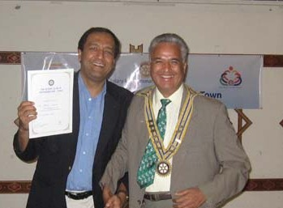
Happy moment ! President Som and Guest Speaker Dr Buddha Basnyat
after handing over a certification of appreciation to Dr Basnyat

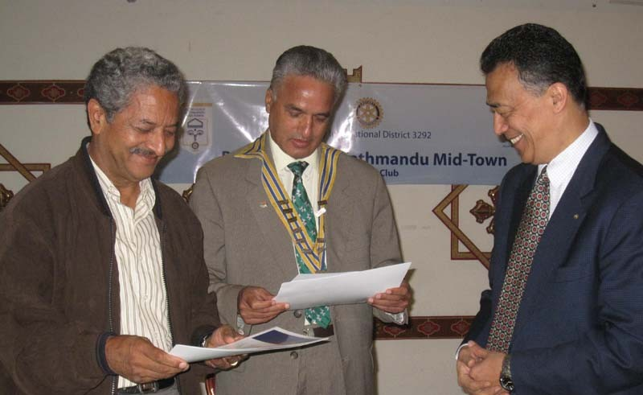
More Smiles !
CP Roop after handing over certificate of appreciation to
President Som and IPP Pratap
received from RI Dist 3292 for their contributions to Peace Conference
held in Lumbini on 26-27 Feb 2011.

Weekly Meetings and Programs :
Date | Program/Speaker | Program/Topics of Presentation
21 October 2011 | Rtn Kul C Gautam | On RI South Asia Conference on Development and Cooperation, held in SriLanka on 4 Sept 2011
28 October 2011 | Holiday | No meeting
4 November 2011 | Rotarians from RC of Landshuit
11 November 2011 | CEO of NCell
18 November 2011 |  | Charter Nite
25 November 2011 |  | Club Assembly

Friday 21 Oct:
Rotary International South Asia Conference on Development and Cooperation was held in Colombo, Sri Lanka on 4 September 2011. Rtn Kul Gautam gave a very interesting presentation in the Conference on ‘Reaching Within – Embracing Human Values’ in the context of South Asia.
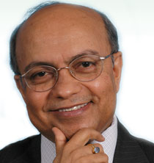
“If the 21st century is going to be an Asian Century, South Asia should strive to position itself at the very heart of such transformation.”
“Rotary can help promote a sense of camaraderie at the people-to-people level”
He will be talking to the Mid-Towners and the guests on Friday morning 21 Oct on this very lively topics. Do not miss it !

Rotarians can support vocational service by
Strengthening the emphasis on professional diversity in member recruitment
Identifying ways to emphasize professions in club activities
Placing a stronger emphasis on business networking with integrity at the club and district level -- which also is a means of attracting and mentoring the next generation
Emphasizing the connection between The Four-Way Test and the Declaration of Rotarians in Businesses and Professions, and their importance to the values of Rotary.

Membership Satisfaction Questionnaire:
Membership Development Committee has recently sent a Membership Satisfaction Questionnaire to all Club members with a request to complete it and return in an attempt to find Club members’ feedback on Club performance. Check your email box, get it and return the questionnaire, duly completed, to lisa@mos.com.np within the deadline. If you decide to do it in hard copy, get a copy from Dahal-ji, and return it, duly completed, to him. The deadline is 15 November.

World Polio Day: 24 October
Rotary’s vast network of 1.2 million members has contributed money, volunteer time, and networking expertise to the polio eradication effort since Rotary began PolioPlus in 1985
Rotary’s financial contributions to the global polio eradication effort will reach nearly US$1.2 billion by the time the world is certified polio-free.
Rotary’s leadership, beginning in 1985, inspired the World Health Assembly to pass a resolution to eradicate polio, which paved the way for the formation of the Global Polio Eradication Initiative in 1988.
Thousands of Rotarians around the world volunteer during National Immunization Days to immunize children.
The PolioPlus program helps Rotary fund operational costs, such as transportation, vaccine delivery, social mobilization, and training of health workers, and support surveillance activities.
Rotarians work to encourage both donor and polio-affected governments to commit the political and financial resources needed to eradicate polio.

The Rotary Foundation Trustees Chair sends a request to Club President:

With your help, we have made tremendous progress in the fight to eradicate polio. We are at an historic moment -- less than 1% away from the end of polio forever. In honor of World Polio Day on 24 October 2011, we are asking for your help to tell the world about Rotary’s achievements and to finish the job
We would like you to encourage your members to participate in two major online initiatives: a 2-for-1 donation recognition campaign and a social media push promoting Rotary’s global polio eradication efforts.
‘2-for-1 Recognition’
During the week of 24-28 October 2011, donors will receive 2- for-1 recognition for every online contribution of US$100 or more made to PolioPlus on www.rotary.org/contribute. We need your help to encourage members to donate online to make this promotion a success. You must be registered with Rotary’s Member Access prior to making an online contribution. Member access provides Rotarians with online services and other important features. To register for Member Access, please visit www.rotary.org/memberacces
The promotion will begin on 6 a.m., Central Standard Time (CST), on Monday, 24 October, and end at 12 noon sharp (CST), on Friday, 28 October. Please note that contributions on www.rotary.org/contribute are in US dollars. Also, online contributions cannot be made on behalf of another individual, club, or district.
‘This Close’
Rally your members and spread the word to friends and family to participate in an exciting online campaign. To encourage widespread support for the effort to eradicate polio, Rotary has recruited a select group of notables for a “This Close” public awareness campaign. These public service announcements emphasize that Rotary is 99 percent toward its goal to eradicate this disease.
You can join the ranks of high-profile participants right now by creating your own “We’re ‘ThisClose’ to Ending Polio” image, sharing with members of your social networks, and encouraging them to do the same by visiting www.thisclose.net.
Together we can celebrate this year’s World Polio Day by bringing global attention to Rotary’s work to eradicate polio. Thank you for your ongoing commitment to Rotary’s End Polio Now campaign.

Polio Plus Week Walkathon:
Participate in Polio Plus Week Walkathon on 24 Oct Monday. The Walkathon will start at 7.00AM from Patan Durbar Square and end at Rotary Hall, Thapathali.

RI Convention 2012, Bangkok:
Register now for the 2012 RI Convention in Bangkok, Thailand, 6-9 May, and enjoy an unforgettable experience in the Land of a Thousand Smiles!
Enjoy Thai hospitality. Make friends with fellow Rotarians from around the world. Take in spectacular sights. Taste delicious Thai cuisine. Experience a vibrant culture. Renew your commitment to Service Above Self. And have fun in a world class city. .
(Source: RI News; Cont’d)

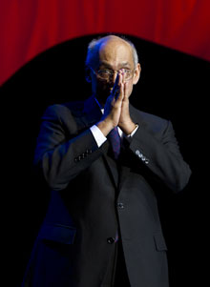
Serving well is the essential first step – but it is only the beginning. We have to raise our profile
with all the tools that are available to us, and there are more tools today than there ever were. ….
Having a website is not enough; it must be up to date, it must be appealing, it must reflect the
work we are doing. And it must offer a way for prospective members, once they see what we
do and become interested, to take the next step.
RI President Kalyan Banerjee

Life with computers:


Please send project/activity information, suggestions and photos etc to :
BC Editor: RR Shrestha email: rryes@wlink.com.np

21 October 2011 The Weekly Bulletin of Rotary Club of Kathmandu Mid-Town bc-10.21/011-12

